Connect with the CAREER CENTER at
MISSOURI STATE UNIVERSITY

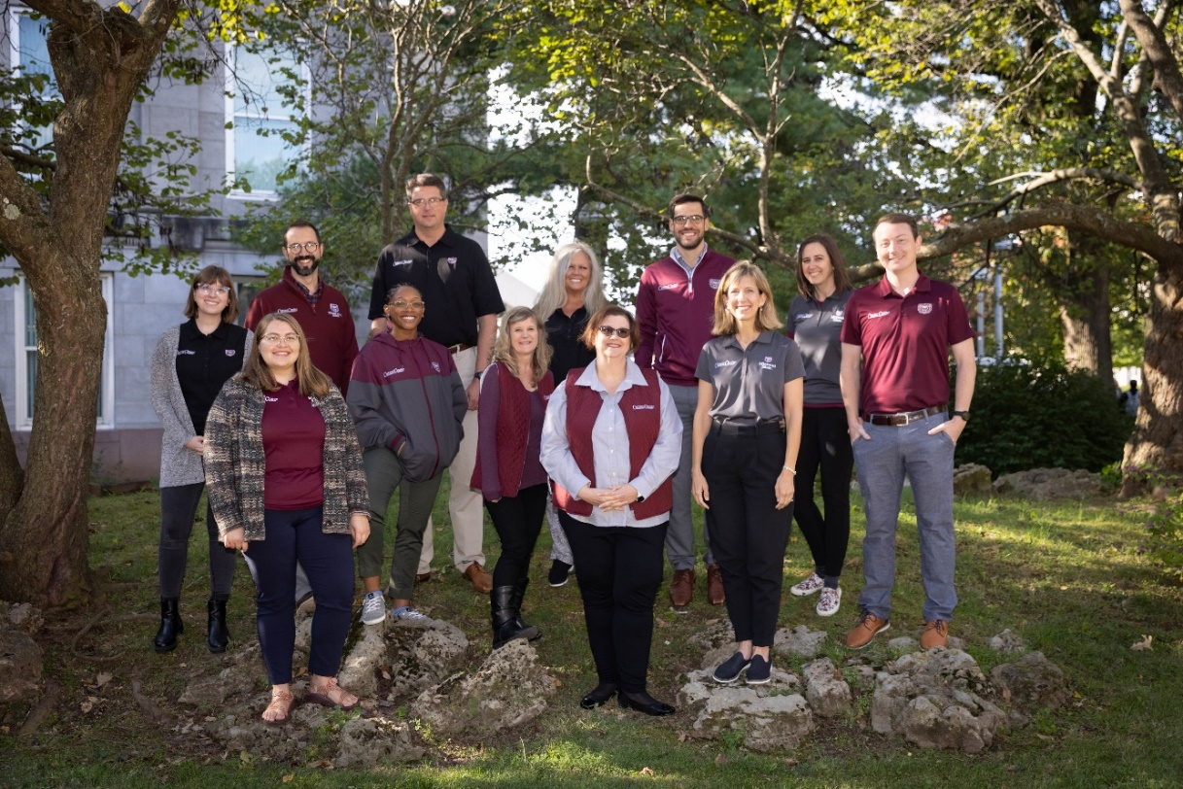
The Career Center is happy to help employers recruit students and alumni by offering a variety of services, such as visiting campus to connect with and recruit students by participating in events, on-campus interviews and more. These services are free of charge.

Please feel free to contact the Employer Relations team to discuss your needs.
- Margie Stewart, Associate Director, Employer Engagement- MarjorieStewart@missouristate.edu
- Sheila Cook, Recruiting Coordinator – SCook@missouristate.edu
- Kam Barker, Graduate Assistant – kab69s@missouristate.edu

Handshake

Missouri State University Career Center uses Handshake as our Career Management Platform. Students and employers can engage to interact with each other, view, and post career opportunities. Related events & fairs are posted through Handshake for all to see by the Career Center.

Learn more about how you can recruit Missouri State University students & alumni:
https://careercenter.missouristate.edu/EmployersAndRecruiters/
Visit Campus: Recruiting Tables & Information Sessions

Schedule a Publicity Table:
Organizations may reserve a table in the Plaster Student Union (PSU) or within certain academic college lobbies. Recruiting tables are most effective when an organization is promoting the company and an opportunity (a job, internship, case competition, office visit, etc.). To schedule a publicity table, the Career Center requires that employers:
- Post a job or internship opportunity or event (case competition, open house, etc.) within Handshake.
- Comply with the Missouri State University Recruiting Policies.
*To request a publicity table, please contact careercenter@missouristate.edu to inquire about available dates.

Host an Information Session:
Organizations may reserve a room in an academic building on the Missouri State University campus for an information session. Organizations often host information sessions before an application deadline or a day or two before an on-campus interview.
*To discuss hosting an information session, please contact careercenter@missouristate.edu with the dates and times you would like to consider for your information session.

Promoting Your Visit:
To promote your visit to campus, the Career Center staff will:
- Post your table date, time and recruitment focus to the Handshake platform.

Scheduling considerations:
Most organizations visit on-campus for 3-5 hours. We recommend scheduling a table Monday-Thursday as fewer classes are scheduled on Fridays. Student traffic seems busiest during the hours of 10:00 am – 2:00 pm, between classes.

On-Campus Interviews
Recruiting through on-campus interviews is an excellent way to connect with talented students and enhance your organization’s on-campus brand. Most on-campus interviews are held in the Career Center’s satellite office. The Career Center staff are happy to discuss on-campus interview processes with you and schedule a visit to Missouri State University!

Conducting on-campus interviews is free but employers must have an approved Handshake Employer Account and positions posted must adhere to and meet the Missouri State University Employer Policies and Principles for Employment Professionals to be scheduled.
On-Campus Interviewing Accommodations:
- Private interview room(s) in Glass Hall or specific academic building conference room(s)
- Complimentary light snacks and beverages
- Reception desk and waiting area for students
- Staff members in close proximity for support
- Access to Wi-Fi so you can work in between interviews
- Additional space for greeters or lunch may be available upon request
On-Campus Interviewing Schedule Options:
- A Pre-Select Schedule is the most frequently used interview schedule. Employers set candidate screening criteria, review resumes and select candidates to interview after the application deadline.
- Open Schedule allows any qualified student to sign up for an interview time; there is no selection process on the employer’s part.
- A Room Only Schedule is for employers who wish to schedule interviews directly with candidates. Many employers with a shorter recruiting timeline have used this option. Room only schedules must still be requested through Handshake
Scheduling Considerations:
- Most on-campus recruitment occurs from September through November and February through April.
- Academic Calendar 2021-2022
  - First day of classes fall semester: August 23
  - Labor Day: September 6
  - Fall Break: October 7 - 8
  - Thanksgiving Holiday: November 24 – November 28
  - Last day of classes fall semester: December 9
  - Fall Final Exams: December 11 – December 16
  - Commencement: December 17
  - Holiday: December 17 - January 16
  - Martin Luther King Jr Holiday: January 17
  - First day of classes spring semester: January 18
  - Presidents’ Day Holiday: February 21
  - Spring Break: March 14 – March 20
  - Spring Holiday: April 14 – April 17
  - Last day of classes spring semester: May 12
  - Spring Final Exams: May 14 – May 19
  - Commencement: May 20

Eligibility for Scheduling On-Campus Interviews:
- Adherence to the Missouri State University Employer Policies

Requirements for Scheduling On-Campus Interviews:
- On-campus interviews - reserved at least three weeks prior to the scheduled interview date
  - Employer must:
    - Have an approved Handshake Employer account connected to Missouri State University
    - Have job(s) or internship(s) posted in Handshake
      - See our Handshake instructions for creating an account and posting a position
  - Employer must not have any outstanding balance with Missouri State University

Requirements for Employers Conducting On-Campus Interviews:
- Maintain confidentiality of students and alumni information in accordance with the Family Educational Rights and Privacy Act (FERPA)
  - In order to protect student confidentiality, employers should refrain from discussing candidate qualifications/performance in public areas of the Career Center including open spaces outside the interview rooms.
- Limit on-campus interviews to Missouri State University students and alumni *
  - Start interviews no earlier than 8:30 am.*
  - Complete interviews by 4:00 p.m. and depart by 4:30 p.m.*

*Exceptions may be made with approval from the Missouri State University Career Center's Employer Relations Team. To request an exception, please contact careercenter@missouristate.edu

Additional Employer Responsibilities:
- Maintain communication regarding on-campus interview reservations and schedules with the Missouri State University Career Center. This includes:
  - Answering inquiries from the Employer Relations Team in a timely manner
  - Canceling room reservations that are no longer needed as soon as possible
  - Communicating all on-campus interview logistics to the recruiting staff who will be conducting the on-campus interviews
  - Sharing the Missouri State University Career Center's recruiting policies with the recruiting staff who will be conducting the on-campus interviews

How to Request an Interview Schedule:
On-campus interview requests may be entered through Handshake. Prior to building an interview schedule, it is recommended to:
- Contact careercenter@missouristate.edu to:
  - Verify room availability for your desired date(s)
  - Discuss positions your company is hiring to ensure it meets our guidelines
  - Discuss special accommodations, if necessary
- View instructions for how to post an interview schedule in Handshake

The Career Center will accommodate employer requests for virtual interviews and information sessions upon request. Follow similar instructions as in-person campus visits.

Calendar of Career Events – Spring 2022
The Career Center invites employers to participate in our career events.
More information is in Handshake in the Career Fairs module

Dates
January 30 – February 5 | JC Penny Suit Up Event | Online Event
February 24 | Career Expo | Springfield Expo Center
February 24 | Education Career Fair | Springfield Expo Center
March 23 | Internship Fair | Plaster Student Union
April 21 | Etiquette Dinner | Plaster Student Union Club
*Check events on Career Center website for any updates.

Connect with Faculty & Departments
Target undergraduate and graduate students whose majors are of interest to your corporation by connecting with one of colleges.

Class Presentations
The Career Center cannot guarantee class visits as it depends on the instructor and their class schedule, but we can connect you with the appropriate academic departments and colleges as they may welcome visitors and virtual guests. To learn more about this opportunity, please contact us at 417-836-5636 or careercenter@missouristate.edu

Student Organizations
Attending Missouri State University Student Organization meetings is an excellent way to meet with students in focused group settings.
- Directory of all Missouri State University Student Organizations

Mentors
If your organization is interested in connecting with and supporting Missouri State University students and alumni through additional involvement, please email us at careercenter@missouristate.edu. Employer opportunities include the following: reviewing resumes, offering mock interviews, hosting job shadow events or site tours. We, as the Career Center staff, look forward to discussing your interests and goals with you.

The two options for “Being a Mentor” include—
- Allowing students to contact you directly to request career advice
- Allowing students to conduct information interviews with you to learn more about your profession

Meet our Bears

Total Student Enrollment: 23618 (Fall 2021)
- Undergraduate Enrollment: 19435
- Graduate Enrollment: 4183

Bears by Ethnicity (Fall 2020)

 | Undergrad | Graduate | Total | %Total
Hispanic | 836 | 159 | 995 | 4.2%
American Indian/Alaska Native | 71 | 21 | 92 | 0.4%
Asian | 349 | 112 | 461 | 2%
Black/African American | 691 | 133 | 824 | 3.5%
Native Hawaiian/Pacific Islander | 22 | 4 | 26 | 0.1%
White/Non-Hispanic | 15735 | 2986 | 18721 | 79.7%
Two or more races reported | 746 | 98 | 844 | 3.6%
Unknown, race not reported | 789 | 96 | 885 | 3.8%
International, all races & ethnicities | 381 | 275 | 656 | 2.8%

Get more Bear Facts: BearStats2020web.pdf (missouristate.edu)

